Implementation of Multi Select and Delete in Interactive grid of Oracle Apex Application :
Interactive Grid Overview :
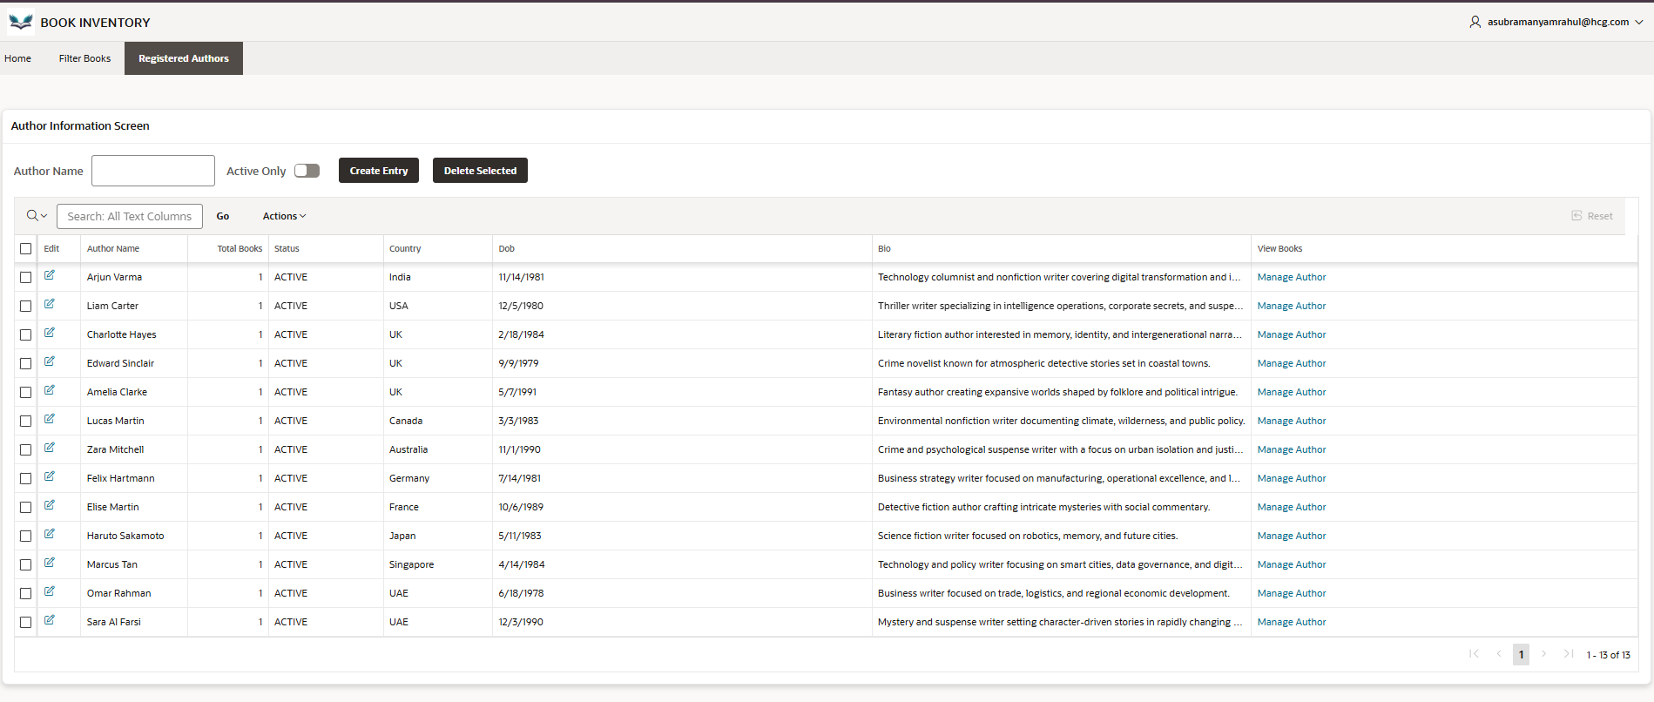
- Step 1: Add a Selector Column in the Source of the interactive Grid :
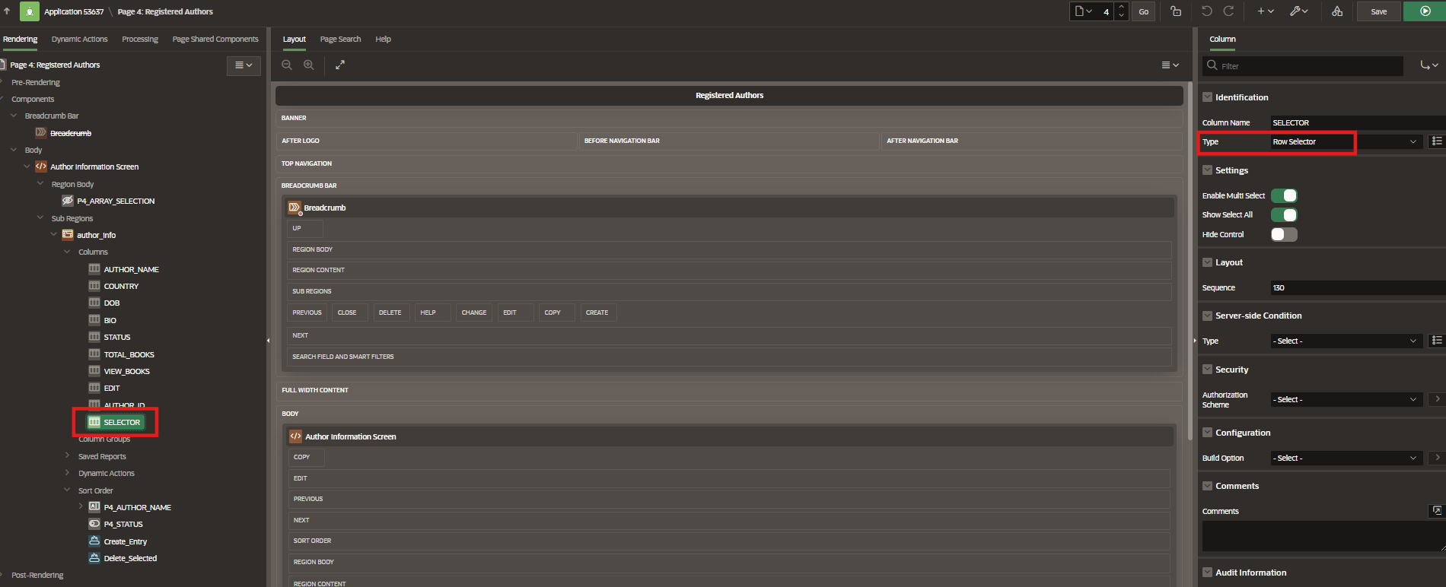

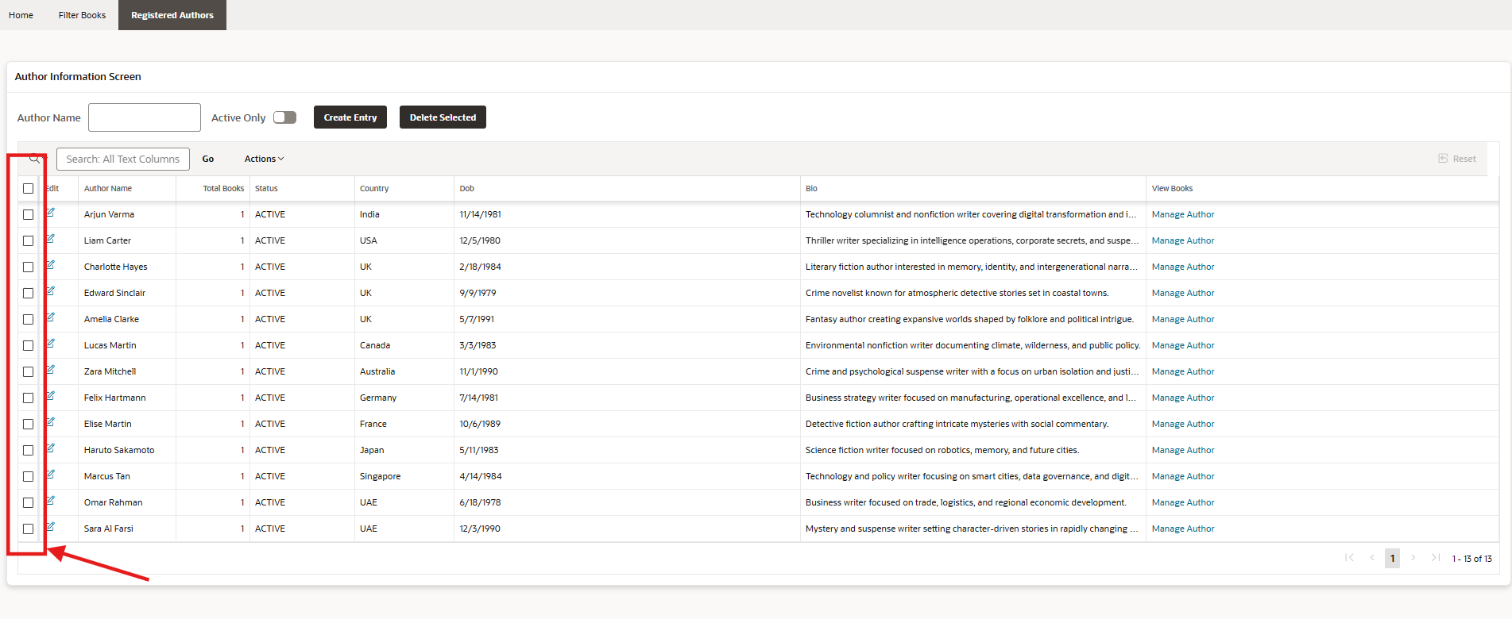
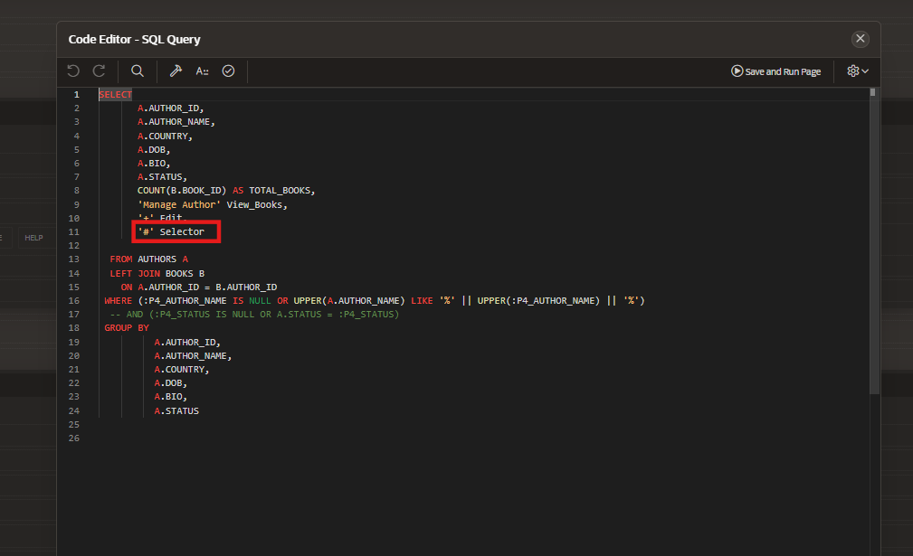

- Step 2 : Add a Dynamic action to insert the selected values into a page level item which acts as an Array Data Structure holding multiple Selection Values
Event : Selection Change[Interactive Grid]
Selection Type : Region
Region : Select the interactive report region
True Action :
We are executing the JavaScript Code
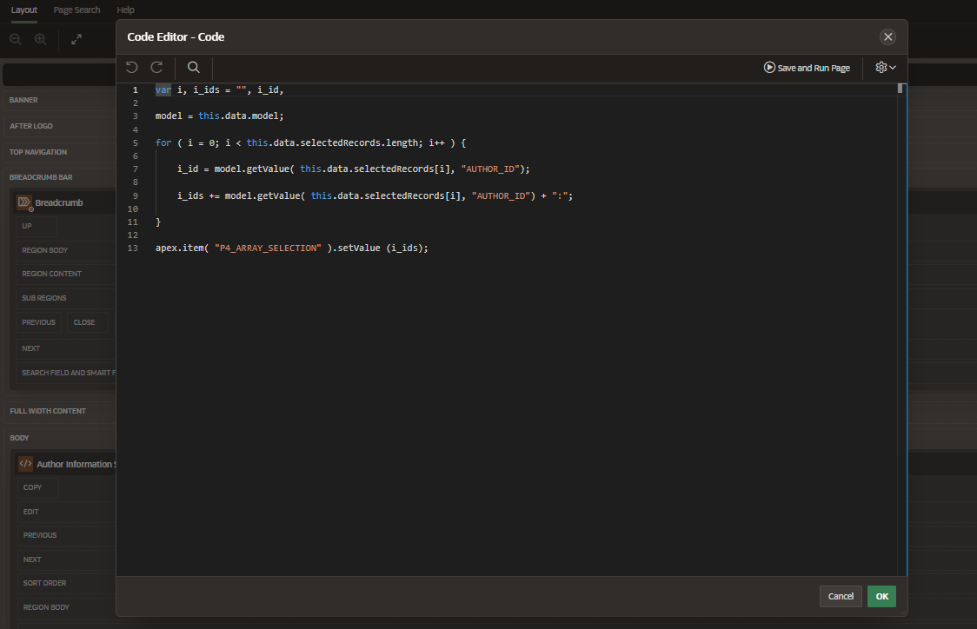

Summary of What the Code Does
- Loops through all selected records in an APEX interactive grid.
- Retrieves the AUTHOR_ID for each selected record.
- Concatenate all AUTHOR_IDs into a single string, separated by colons :.
- Stores that string in an APEX page item (P4_ARRAY_SELECTION)
P4_ARRAY_SELECTION
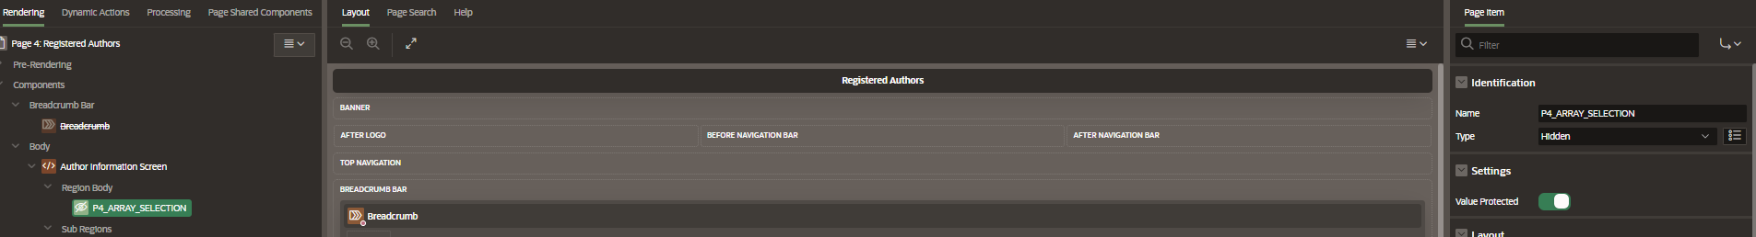

Whenever there is a change in the selection of the interactive report region ,
The Selected items are being populated into the Page item P4_ARRAY_SELECTION and are being stored.
To delete the selected records , a button is created and a process gets implemented whenever the ‘Delete Selected ’ button is pressed.
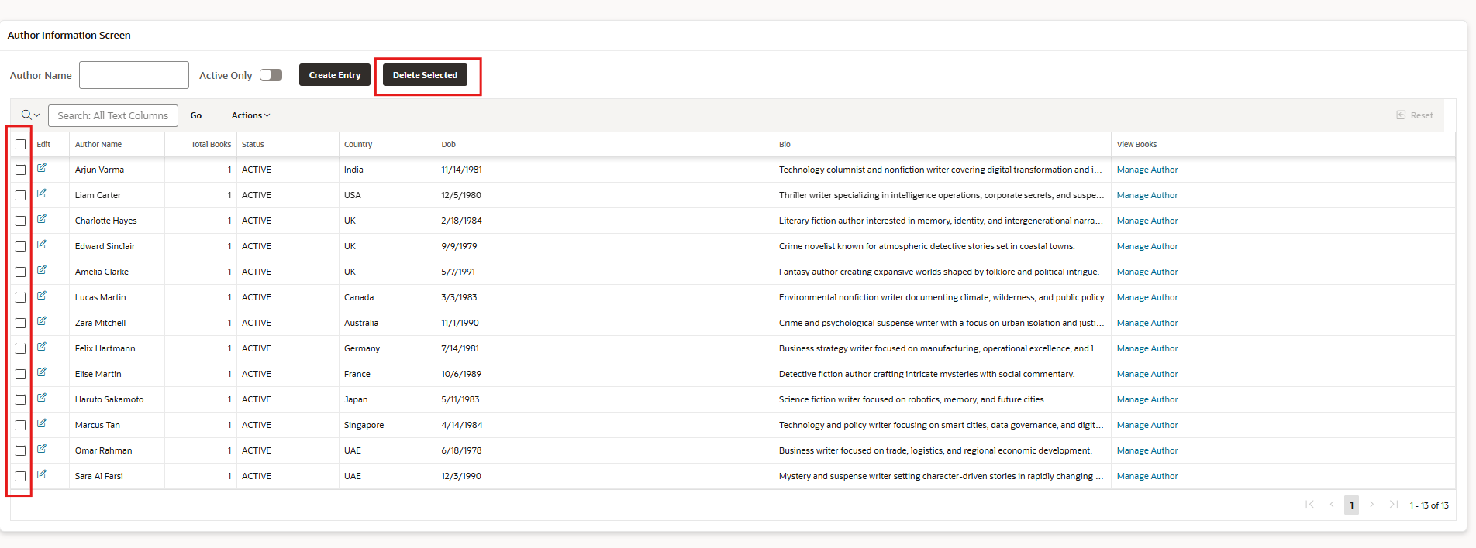
Step 3 :
Add an application process to delete the selected Records which gets triggered after clicking on that button :
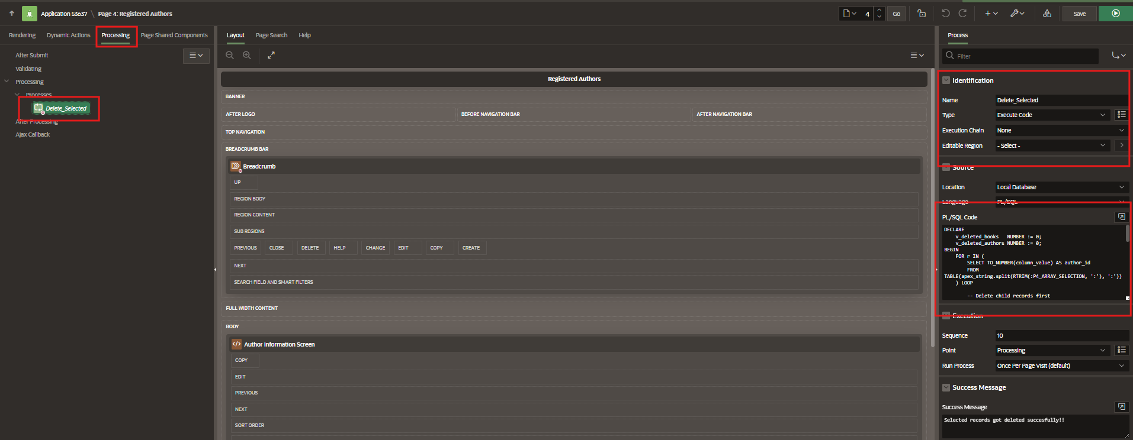

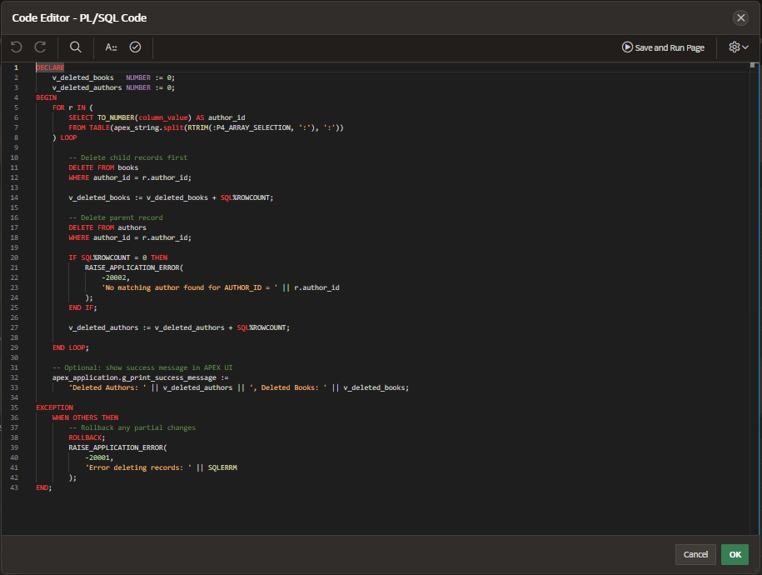
Summary
- Reads author IDs from a colon-separated list.
- Deletes books first (child table) and then authors (parent table).
- Keeps counters of deleted records.
- Show’s success message in APEX.
- Handles errors safely by rolling back and raising meaningful messages.

This process Loop Through Selected Author IDs :
- :P4_ARRAY_SELECTION → Contains the colon-separated AUTHOR_IDs (from your earlier JavaScript).
- RTRIM(..., ':') → Removes the trailing colon from the string.
- apex_string.split(..., ':') → Splits the string into individual values.
- TO_NUMBER(column_value) → Converts each split value into a number.
- r.author_id → Each author ID for this loop iteration.

Deleting the Records :

Select the entries :
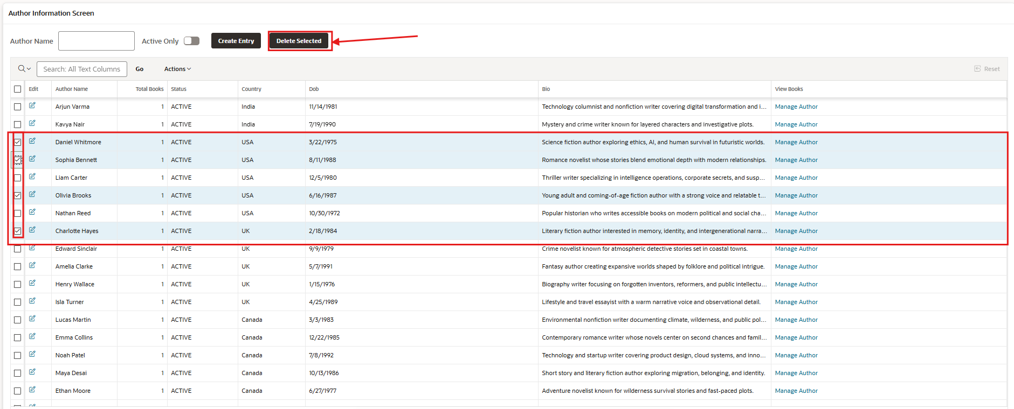

Record Count Before Deletion :
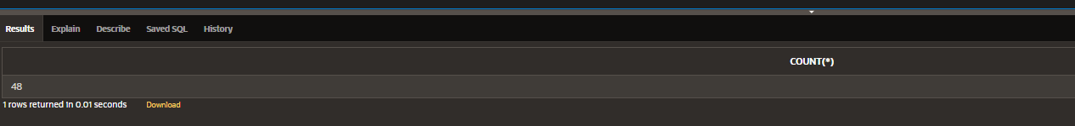
Total number of Records selected for deletion : 4

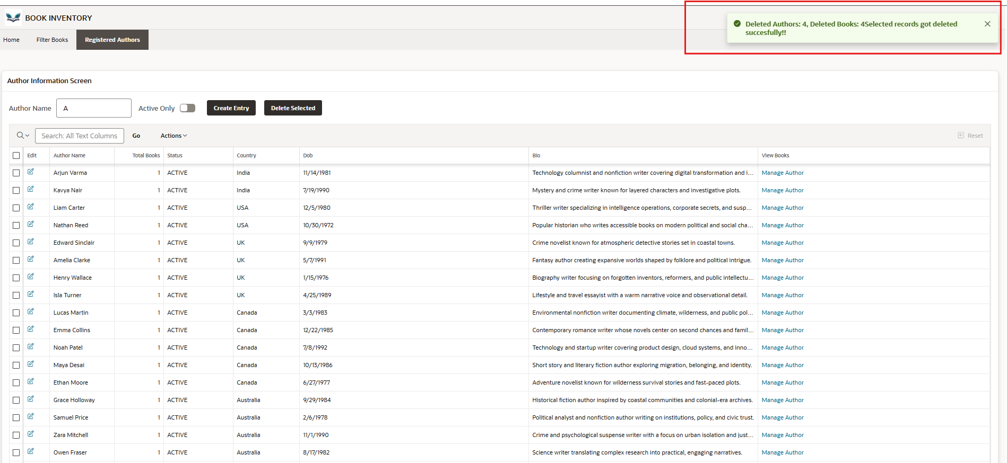

After Deletion :
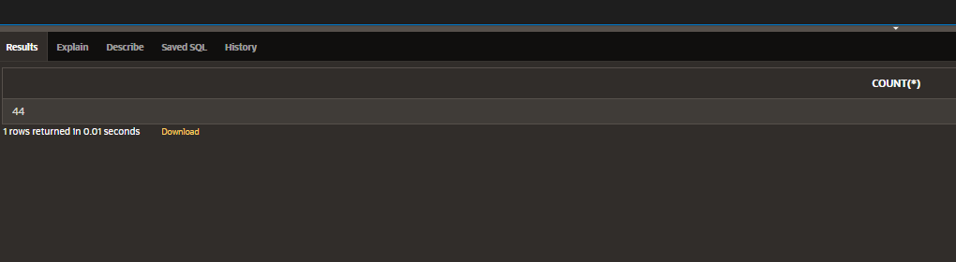

Exporting the Application :
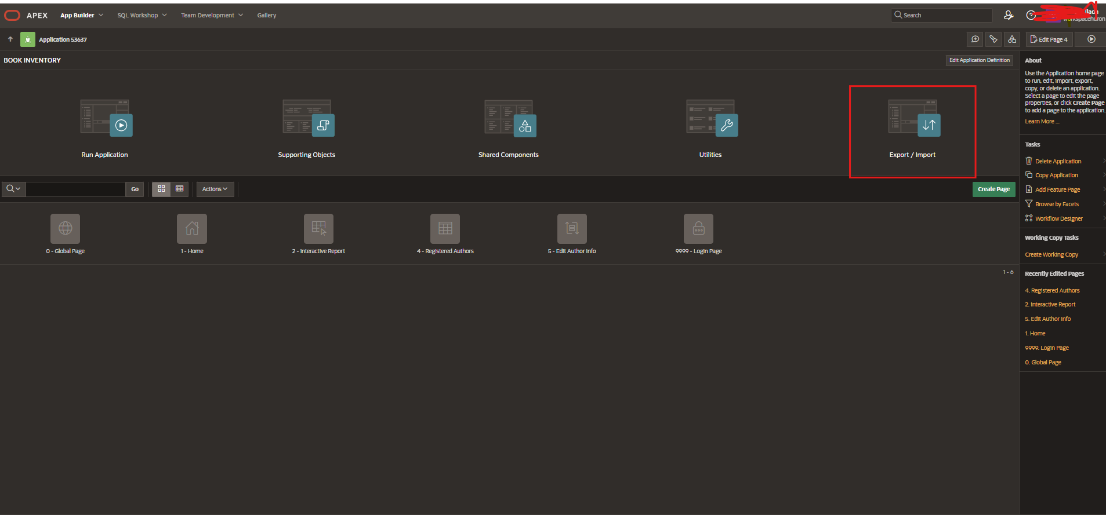
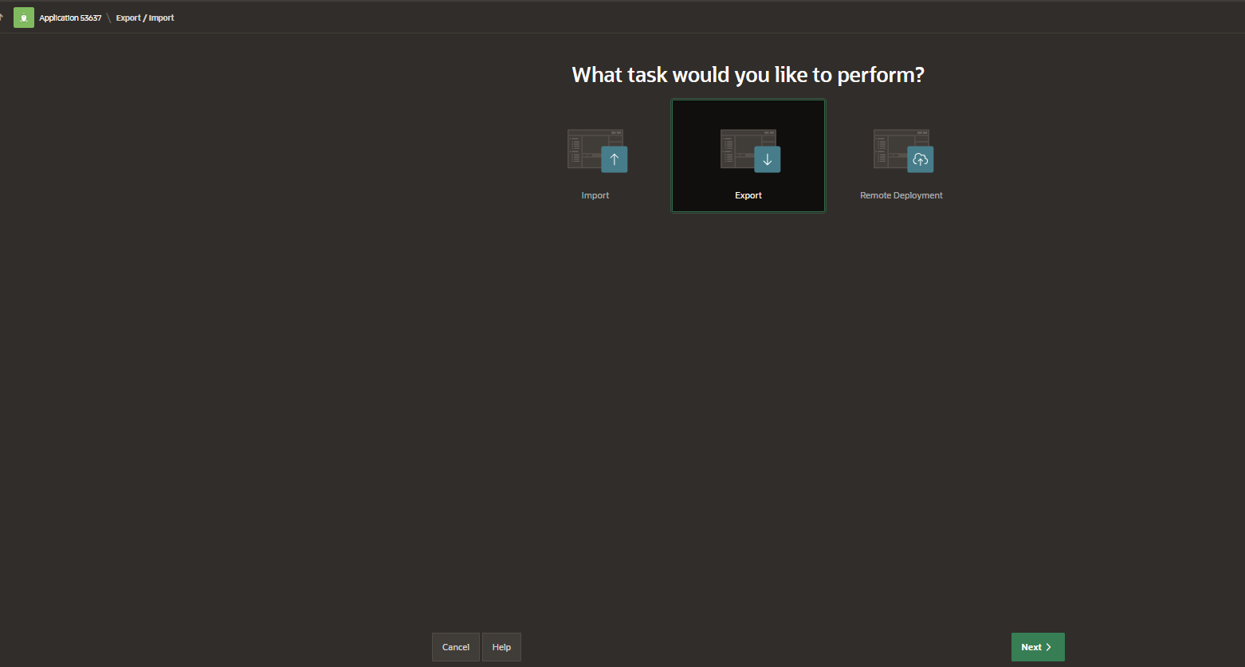
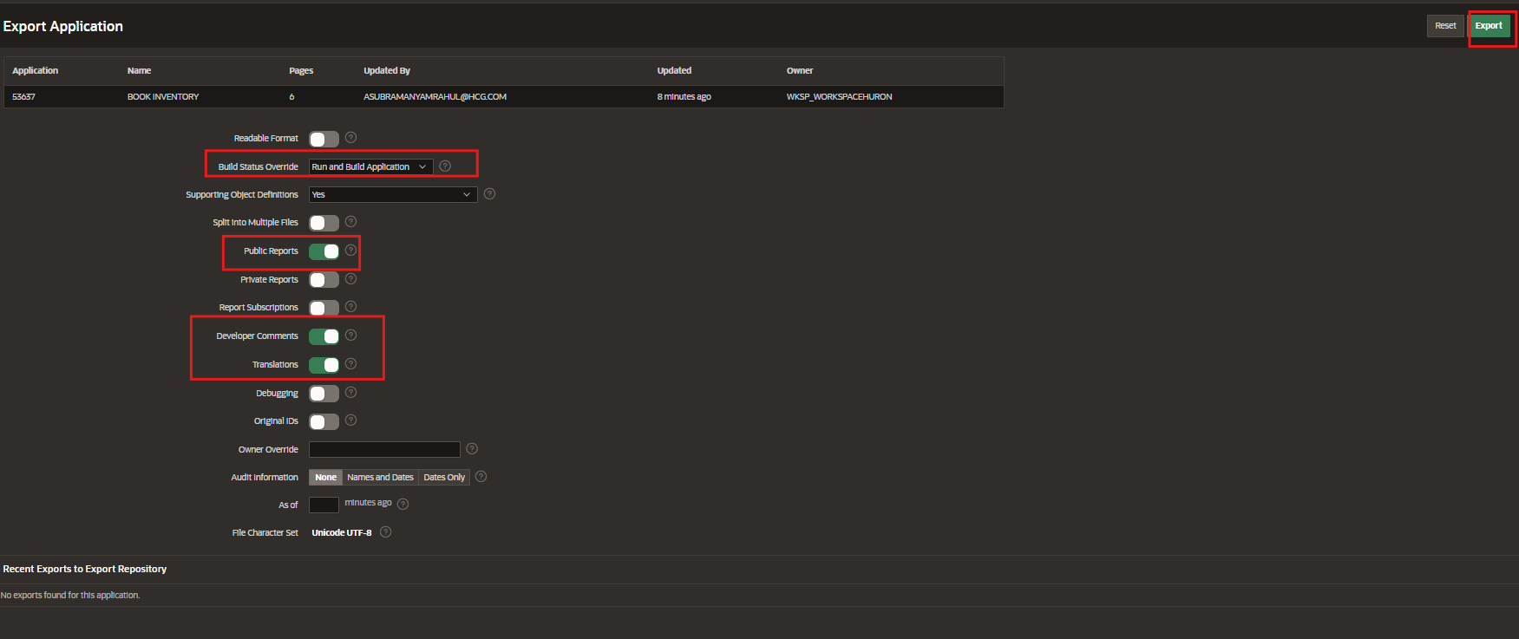
After Exporting the SQL File has been created Successfully :
